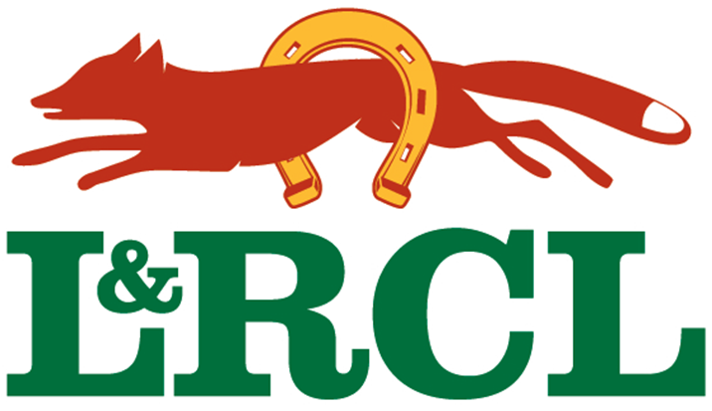
Leicestershire & Rutland Cricket League sponsored by Everards.
www.landrcl.net
Chairman: Nigel Kinch  n.kinchhaulage@btinternet.com | Vice Chairman: Chris Pople  chris_pople@sky.com | Treasurer: Brad Peake  bjpeake@btinternet.com | Secretary: Ged McDougall  ged.mcdougall@ecb.co.uk

Application to join the Leicestershire & Rutland Cricket League

Please complete the form below and return it to:

Ged McDougall – ged.mcdougall@ecb.co.uk

Club name

Ground address

Year formed.

Number of teams

Secretary's Name

Secretary's
Address,

Phone number

email address

If your application is accepted, new clubs will be required to have the following in place before their 1st season:

- Confirmation of use of their ground for the whole summer (April to September).
- Ground inspection carried out by the league to grade facilities.
- Club constitution
- Public liability insurance to £5m.
- Bank account in club name
- Covid 19 risk assessment.
- Captains to have up to date DBS check.

A representative of the League will be in touch with you to discuss your application.

